Game Design Document

Fill up the following document

Name: Pragna R. Kadu , Whjr

1. Write the title of your project.

-Chocolate Run

1. What is the goal of the game?

The goal of the game is to collect chocolates to gain more energy to save oneselves from the monster

1. Write a brief story of your game.

The game is about saving PC’s life from the monster and run to save it’s life. The PC has to collect chocolates to increase it’s velocity and to get saved from the monster. There would be many obstacles in PC’s route , which it has to cross .If it dashes from the obstacles or if the PC is unable to collect the chocolate then it’s velocity will decrease, and then the monster would also be able to catch the PC easily. The velocity of the background will also increase as the frame count increases.The player would also have to create a high score , to beat it the next time, when he is playing the game.

1. Which are the playing characters of this game?

* Playing characters are the ones who respond to the user based on the input from the user.
* Cars, monkeys, dinos, wizards, etc., are the playing characters in the game.

|  |  |  |
| --- | --- | --- |
| Number | Character Name | What can this character do? |
| 1 | Dustin(a man) | This character is the one who is going to collect the chocolates,and save it’s life from the monster |
| 2 |  |  |
| 3 |  |  |
| 4 |  |  |
| 5 |  |  |
| 6 |  |  |
| 7 |  |  |
| 8 |  |  |

1. Which are the Non-Playing Characters of this game?

* Non-Playing characters are the ones that don't have an action or behavior when the user interacts with the game.
* Hurdles, stones, bananas, coins, etc., are non-playing characters in the game.

|  |  |  |
| --- | --- | --- |
| Number | Character Name | What can this character do? |
| 1 | Monster | He has to chase and eat the Player/ Dustin |
| 2 | Puddle(obstacle) | If the player touches or falls in the puddle, it’s velocity will decrease |
| 3 | Chocolate | When the player touches it , the players speed will increase |
| 4 | Bush(obstacle) | If the player touches the bush, it’s velocity will decrease |
| 5 | Tortoise(obstacle) | If the player touches the Tortoise, it’s velocity will decrease |
| 6 |  |  |
| 7 |  |  |
| 8 |  |  |

Draw your imagination of this game. What does this game look like?

* Draw the game either on your computer or on paper.
* Add images of the game scenes to show each of the playing and non-playing characters at least once.

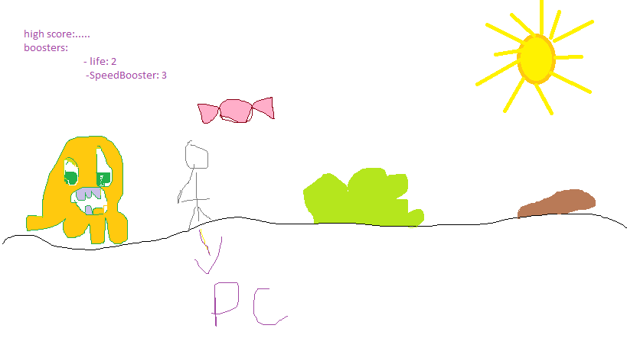

How do you plan to make your game engaging?

I will make the game engaging by adding sond effects , when the Player creates high score , breaks high score , touches obstacles ,collects chocolate, and when it is eaten by the monster. I will increase the velocity of the background after certain frame counts. I will add nice background image.I will calculate the high score and display it on the screen .

I would make velocity booster , that the user can you a certain time , as per the availability of the booster with the player.